XPON STICK Product User Manual
- Product Introduction
Product Name: XPON STICK ONU (GPON/EPON Adaptive), commonly known as "Cat Stick"
Chip Solution: Galachip GC1601A
Product Features:
- 3.3V power supply, maximum transmission distance of 20KM
- Supports data encryption
- Compatible with SFP MSA
- Supports VLAN function configuration
- RoHS compliant
- Supports online software upgrades
- Supports fault alarms
- Supports dynamic bandwidth allocation
- Supports multicast transmission
- Compatible with SC/APC or SC/UPC interfaces

- Application Scenario Overview
The XPON STICK optical module, referred to as the "SFP (SFP+) packaged PON ONU module" in China Telecom's enterprise standards, is primarily used to replace SFU optical modems, enabling gigabit (10-gigabit) single-port photoelectric conversion in PON networks.
The XPON STICK optical module fully meets the requirements of telecom-grade FTTB/FTTH/FTTO equipment. It can be hot-swapped into the SFP slot of a Layer 2 Ethernet switch, allowing the entire device to function as an ONT. This enables the device to directly connect to the GPON optical network. The central office OLT only needs to register the GPON STICK optical module like a regular optical modem, and the communication device can complete the switch from the original P2P network to the PON network.

- Usage Instructions
(1) Insert the STICK module into the optical port of a switch or router and check if it can be pinged.

STICK module IP address is 192.168.1.1
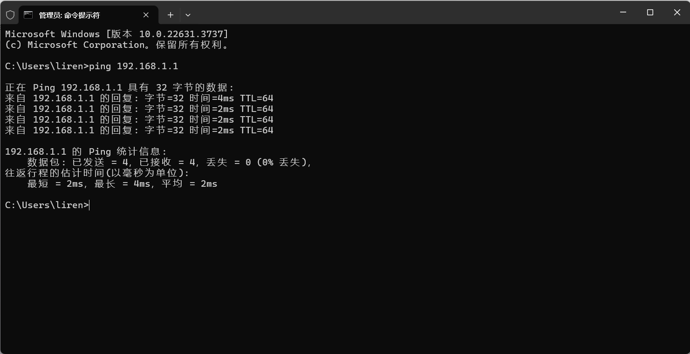
User name：root
password：root
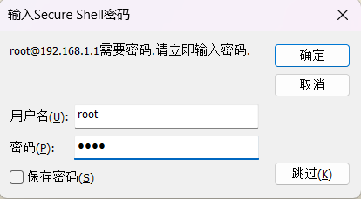

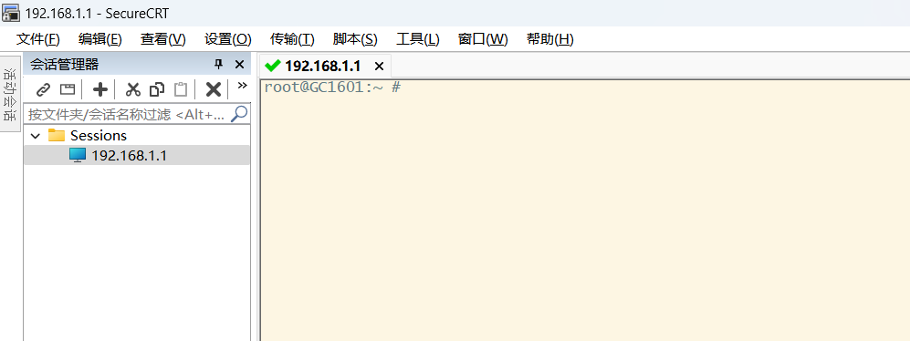

(2) Main operation commands
Query MAC address ---gccli sys mac
root@GC1601:~ # gccli sys mac
Mac Address: 80:A5:79:50:01:31
root@GC1601:~ #
Modify MAC address---gccli sys mac xx:xx:xx:xx:xx:xx，then input gccli sys save to save
root@GC1601:~ # gccli sys mac 80:A5:79:50:01:32
sys mac success
root@GC1601:~ # gccli sys save
sys save success
root@GC1601:~ #

Open tx power---gccli gpon tx 1
root@GC1601:~ # gccli gpon tx 1
root@GC1601:~ #

Close tx power---gccli gpon tx 0
root@GC1601:~ # gccli gpon tx 0
root@GC1601:~ #

Open rx power----gccli gpon rx 1
root@GC1601:~ # gccli gpon rx 1
root@GC1601:~ #

Close rx power----gccli gpon rx 0
root@GC1601:~ # gccli gpon rx 0
root@GC1601:~ #

Turn on the long glowing light ---gccli bob prbs_set 2
root@GC1601:~ # gccli bob prbs_set 2
Bob chip_type: UX3320
gccli bob prbs_set OK
root@GC1601:~ #

Close the long glowing light ---gccli gpon rogue 0
root@GC1601:~ # gccli gpon rogue 0
root@GC1601:~ #

Query GPON status---gccli gpon status (normally los is 0)。
root@GC1601:~ # gccli gpon status
los = 1
state = O1
fec = 0
root@GC1601:~ #

Login to web interface - Enter 192.168.1.1 address in the browser, and the login interface will pop up,

username：admin
Password: admin
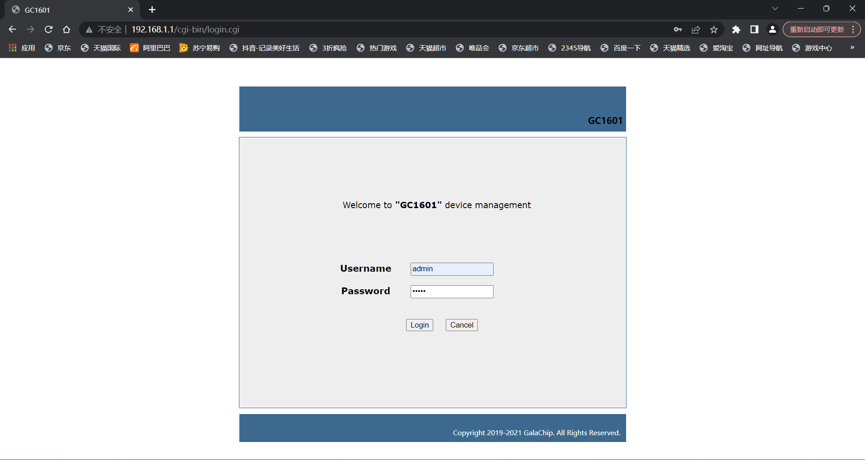

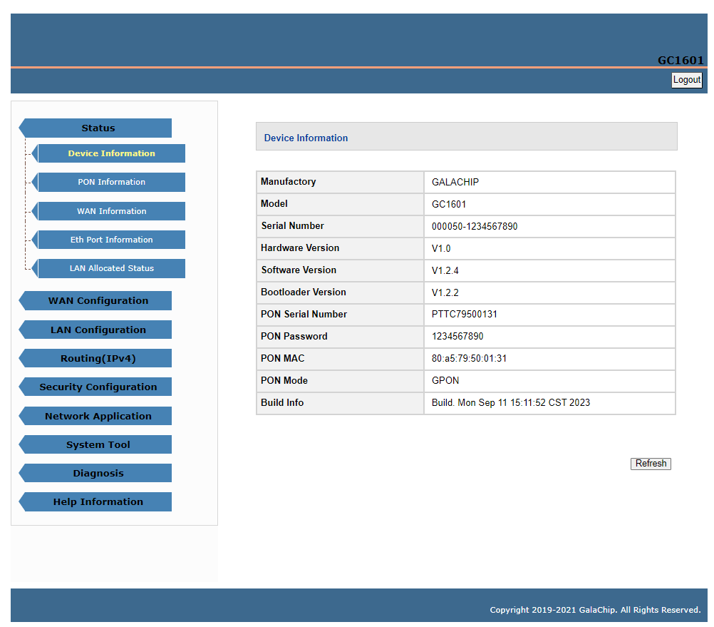

4. Adapting devices
1）OLT
Mainstream brands such as ZTE, Huawei, Nokia, etc.
2) Switch
Huawei, H3C, TP-LINK， Cisco and others.
The adaptation devices are continuously being updated

